**Chapter 4**

**Hand Gesture Detection**

**4.1 Introduction**

Object detection plays a very important role in my own dataset. To analyze and extract relevant data about an object of interest from an image, one needs to first get that object in the image. Hand posture detection refers to finding the place and size of hand within a sequence of images. Nowadays it is a very popular problem in computer vision problem and has many numerous applications, such as gesture recognition, sign language recognition, computer graphics games, and human-computer interaction (HCI).

Skin color [21, 22, 23] is an important property to detect hand and tracking. However, Color image has the different problem of removing other objects with similar colors such as face and human arm. To solve this problem, we introduce a new method to detect hand postures only using face detection and subtraction, skin detection, and hand postures contour detection and comparison algorithm [24]. The face was detection removed because the skin detection will detect the face and the face’s contours are very similar to the first-hand gesture contours. An interest of the area has been captured and another same skin color has been removed from an interest of the area. After removing an unwanted area of the face, I detected the skin area using the hue, saturation, value (HSV) color model since it has real-time performance and it is strong against alternations, scaling and lighting conditions. Than, the interested area of contours was compared with all the existing hand posture template contours to eliminate unwanted interest of area like objects existing in the image.

**4.2 Hand Detection Approaches**

There are different approaches for hand detection have been introduced in the literature that employs different visual features and, in many cases, their combination. These are different approaches such as motion, skin color, shape, and 3D models of hands. Hand detection methods were discussed in [25] and will be discussed later in this chapter.

**4.2.1 Color**

Skin color detection has been used in many hand gesture recognition projects. The main objective of giving a model of skin color is the choice of the color space to be utilized. Different color spaces have been introduced such as RGB, normalized RGB, HSV, YCrCb, and YUV. Color spaces that effectively divide the chromaticity from the luminance parts of color are typically regarded as preferable as I did in my approach by removing the Value (V) section in the HSV model. This is because of employing chromaticity-dependent mechanisms of color only.

Generally, hull color detection can be disordered by background objects that have a hull color distribution like human skin color. Some project has been done on this problem by using background subtraction [26, 27]. On the contrary, it was expected that unwanted background subtraction normally depends on the camera system that does not move with respect to a fixed background. Another solution [28, 29] has applied the dynamic modification of background compensation techniques.

**4.2.2 Shape Hand**

Shape property has been working to discover in frames. More details can be acquired by reducing the contours of objects in the frame. If the contour is perfectly detected, it provides a good presentation of the hand gesture which is indirectly related to a viewpoint, skin color, and lighting. Typically, contour extraction based on edge recognition uses many edges fitting to the hand image area but also to distinct background objects.

Accordingly, sophisticated post-processing techniques are needed to develop the presentation of this method such as our approach in [24] by combining skin color detection with contours detection and comparison after face subtraction. A second method that has been used in fingertip finding is pattern matching. Patterns can be images of fingertips [30] or fingers [31] or generic 3D cylindrical models [32]. These pattern matching methods can be upgraded by using extra image features such as contours [26].

**4.2.3 Learning Detectors from Pixel Values**

Currently, this technique that uses a machine learning method named posting has shown remarkably strong results in face recognition and good results in hand recognition [33]. In [34], an object recognition method was proposed in which a weak classifier may be a simple finder that uses basic image block differences efficiently calculated using an integral image. On the other hand, this technique may provide an unnecessary number of weak classifiers. The AdaBoost technique has a drawback because it does not consider the removal of chose weak classifiers that no longer take part in the recognition procedure. Also, there is some problem to distinguish the hand using the Viola-Jones method [34, 35] related to rotation and cluttered background.

**4.2.4 3D Model-Based Detection**

One major advantage of a 3D model-Based method is that it can allow for view-independent detection. The used 3D models must have enough degrees of freedom to adapt to the dimensions of the hand that exist in an image. Different mock-ups use different image features to build feature-model communications. Line and point features are applied in kinematic hand models for recovering angles created at the links of the hand [36, 37, 38]. The hand gesture is then estimated based on the relations between the 3D model and the observed image features.

**3.2.5 Motion**

Motion is a dynamic feature employed by some procedures for hand detection. Motion based recognition requires a highly controlled arrangement, and it adopts that the only movement in the image resulted from hand motion. In the case of fix cameras, the issue of movement assessment is solved with background maintenance and successive removal. This explanation is employed in [50,51] for recognizing the hand from other skin- colored objects, and for testing with lighting conditions resulting from colored lights. The difference in pixel strength between two consecutive frames is close to zero for the background pixels. Motion objects are placed by selecting and maintaining a suitable threshold.

**4.3 My Approach for Hand Detection**

 I propose an integrated system for detection, segmentation, and tracking of the hand in a gesture recognition system using a single webcam. Some other methods that use color gloves [39, 40], my method can detect the plain hand posture by integrating two useful features: skin color detection and contour matching. My proposed hand posture, finding algorithm has real-time performance and is strong against rotations, scaling, a cluttered background, and lighting conditions. Section 4.4.2 shows the strength of my proposed hand posture detection algorithm based on comparison with other different methods. Detecting the human hand in a cluttered background will boost the performance of hand gesture recognition systems used in Chapter 5. In this method, the speed and result of recognition will be the same for any frame size taken from a webcam such as 640×480, 320×240 or 160×120 and the system will be also robust against a cluttered background because I process the detected hand posture area only. A smaller image size that holds the detected hand posture area only must be like the training image size of a training stage as I will discuss the training and testing recognition systems stages in Chapter 7.

 To detect the hand gesture in the image, a four phase system was designed according to my approach and as shown in Figure 4.1. First, we will open camera which has 50 square box to capture hand gesture. Second Put your hand in those boxes and make sure your hand covers all the square box. Third, the skin color locus for the image was removed from the user’s skin color after face deletion. Then the last step, the hand gesture was spotted by removing false positive skin pixels and identifying hand gesture and other real skin color regions using contours matching with the loaded hand gesture pattern contours. Skin Recognition Area Loading Hand Postures Patterns Contours Face Detection and Subtraction Capturing Images from Webcam or Video file Templates Contours Comparison with Skin Area Figure 4.1: Hand posture detection steps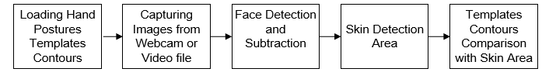

**Figure 4.1 Hand posture detection steps**

**4.3.1 Skin Detection**

Skin detection is a useful approach for many computer vision applications such as face recognition, tracking and facial expression, abstraction, or hand tracking and gesture recognition.There are recognized procedures for skin color modeling and recognition that will allow to differentiate between skin and non-skin pixels based on their color**.**To get suitable distinction between skin and non-skin areas, a color transformation is needed to separate luminance from chrominance [42].

The input images normally are in Color format (RBG), which has the drawback of having components dependent on the lighting situations.The misunderstanding between skin and non-skin pixels can be decreased using color space transformation**.**There are different approaches to detection skin color components in other color spaces, such as HSV, YCbCr, TSL or YIQ to provide better results in parameter recovery under changes in lighting condition. Researches have shown that skin colors of individuals cluster closely in the color space for all people from different societies, for example, color appearances in human faces and hands vary more in intensity than in chrominance [41, 43].Thus, take away the intensity V of the original color space and working in the chromatic color space (H, S) provides invariance against illumination situations. In [42], it had been well-known that removal the Value (V) component and only using the Hue and Saturation components, can still permit for the detection 96.83% of the skin pixels.In my application, I use the hue, saturation, value (HSV) color model since it has shown to be one of the most adapted to skin-color detection [44].It is also well-matched with the human color perception. In addition, it has real-time execution and it is more robust in cases of rotations, scaling, cluttered background, and changes in lighting condition.So, my projected hand gesture detection algorithm is real-time and robust against the mentioned previous changes.The other skin like objects existing in the image are removed from contour comparable with the loaded hand postures prototype contours**.**

The HSV color space is gained by a nonlinear transformation of the essential RGB color space.The conversion between RGB and HSV was described in [45].Hue (H) is a section that characterizes a pure color such as pure yellow, orange or red, whereas saturation (S) provides a measure of the degree to which a pure color diluted by white light [46]. Value (V) attempts to represent brightness along the gray axis such as white to black, but since brightness is subjective, it is thus difficult to measure [46].

According to [47] and Figure 4.2, Hue is estimated in HSV color space by a position with Red starting at 0, Green at 120 and Blue at 240 degrees.The black mark in the diagram at the lower left on the screen determines the hue angle.

Saturation is a ratio that ranges between 0.0 along the middle line of the cone (the V axis) to 1 on the edge of the cone.Value ranges, string from 0.0 (dark) to 1.0 (bright).

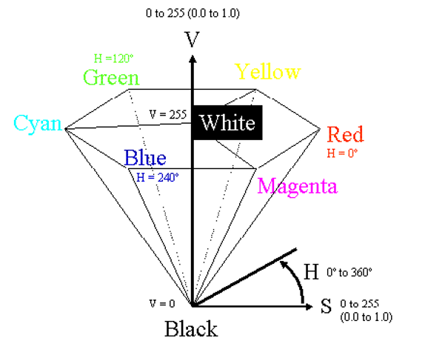

**Figure 4.2 HSV Color Space[47]**

According to [41],the HSV model can be resulting from non-linear transformation from an RGB model according to the following calculations.

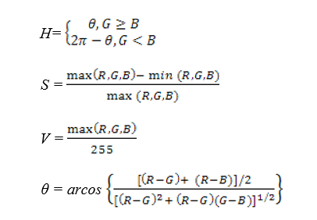

4.1

4.2

4.4

4.3

As per a classification point of view, skin-color detection divided into two class problem: skin-pixel vs non-skin-pixel classification. Currently, there are different known classification approaches exits such as thresholding, Gaussian classifier, and multilayer perceptron [48, 52, 53].

In my research, I used a thresholding technique that allows getting a good result for higher computation speed when compared with other techniques, given our real-time requirements. This thresholding classification is used to find the values between two components H and S in the HSV model as I removed the Value (V) component. Usually, a pixel can be observed as being a skin-pixel when the following threshold values are synchronized satisfied: 0° < H < 20° and 75° < S < 190°.

**4.3.2 Contour Comparisons**

Once the skin color has been detected, the contours of the detected skin color are recovered and then compared them with the contours of the hand gesture patterns. Once skin color contours are recognized as belonging to the hand gesture contour patterns, that area will be identified as a region of interest (ROI) which will then be used for tracking the hand movements and saving the hand posture in JPEG format in small images as shown in Figure 4.3. After that stored images will further be used to extract the features needed to recognize the hand postures in the testing stage as discussed in Chapters 5.

|  |  |  |  |
| --- | --- | --- | --- |
|  |  |  |  |

**Figure 4.3: Images of detected hand postures.**

If there is both hand gesture in the image, my system will substitute in detecting one of the two hands for every frame captured because the Open Computer vision function cvBoundingRect will circle one rectangle only around the detected hand, which has the main matching contours with the overloaded hand posture templates contours. The single frame will circle the detected hand posture for one frame and may enclose the other hand posture for the next frame if it has a higher matching contour.